**Internet of Things Home Monitoring System**

ECE 597 Fall 2016

Zhihao Xue

Department of Electrical and Computer Engineering

Rose-Hulman Institute of Technology

10 November 2016

Contents

Introduction 2

IoT Home System 2

Objectives 2

Design Strategy 2

Trial and Error 2

Parts List 4

Spare Parts List 4

Assemble Hardware 5

Operation System, Software, Platform and Code 6

Operation System for Raspberry Pi 3 6

Software and Platform 11

Bluemix 11

Node-RED 15

Code 22

Display on the Internet 24

Conclusions 27

Acknowledgements 27

# Introduction

With the development of the Internet, wearable devices, compatible sensors. We are now entering an era of data. The Internet of Thing (IoT) refers the devices embedded with various sensors and connect to the Internet.

The IoT home monitoring system is aim to help people surveille their home from and get up-to-date information from remote via the Internet.

The goal of this project is to create a system that has the capability to use different sensors to capture ambient data, capture live video streaming and publish this information to the Internet via some cloud service.

The end result of this project is able to modify this system, add or remove any sensors and have a live dashboard to display all these senor data. And you are able to share this dashboard to anyone you would like to.

# IoT Home System

## Objectives

The goal of the project was to build a real-time supervisory system that uses a microcontroller to interface with different sensors to capture designated environmental data and find a way to visualize them.

## Design Strategy

1. Find a suitable microcontroller for this project
2. Write and optimize code for video streaming
3. Implement code to capture and process sensors data
4. Connect the microcontroller from local to the cloud
5. Transmit local data to the Internet
6. Publish and demonstrate the captured data

## Trial and Error

The aim for this system is to build a very rudimentary monitoring system to surveille in-door scenes and ambient environment information, such as temperature. Thus, a low power-consumption controller with multiple inputs and outputs is what I wanted. In addition, this controller should integrate with Internet connection, such as Wi-Fi or Ethernet port.

The first choice is the Intel® Edison and Arduino Breakout Kit (see Figure 1). This kit includes both Edison chip and an Arduino interface. The original thought was to use the Edison’s powerful computational resource (Intel Atom dual-core CPU with 500MHz speech) and plenty Arduino sensors and libraries to build this system. However, when I tried to run some test program on via Arduino interface. The compiler gives me some errors. And these errors are about kernels, which means I can do little to fix them. One concern about these errors is due to different complier version. The up-to-date Arduino compiler version is higher than the Kit’s default. This answer is found in one thread in Arduino official forum.

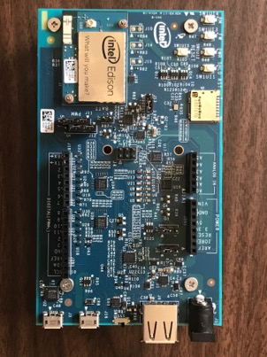

Figure 1 Intel® Edison and Arduino Breakout Kit

However, beside Arduino, Edison also support Linux. With its setup tool (can find here: <https://software.intel.com/en-us/get-started-edison-windows-step2> ), it is easy to refresh its firmware on a Yocto Linux project. On Linux system, I can run native Python program to control different GPIO ports and USB web camera.

There is another concern makes me eventually to abandon Edison is about live streaming. With Yocto Linux, I can install some Python packages such as numpy, opencv and flask. I can use these packages to setup a local server to host video streaming from a USB web camera connected to Edison via opencv. One issue is this so-called video streaming is actually a serious of static images captured by the camera in a very short time duration, then sent them frame by frame to the host to mimic a video stream. Under this condition, the video looks like stop motion animation. It is only about 5-10 frames per second. The other issue is using Flask. It did help me setup a local server to display the video. But it is hard to broadcast this video to the Internet. In other words, the user must log in this system, then they can watch this stop-motion streaming.

To solve this low fps problem and broadcast to external network, ffmpeg and YouTube provide a feasible solution. You can live streaming your webcam on YouTube for free. And as long as you have enough bandwidth and high definition camera, you are able to streaming the video up to 1080p. All you need is setup ffmpeg including frame size, fps, bitrate, video format, and the YouTube URL. This URL is unique and provided by YouTube. You can find you stream name/key here: <https://www.youtube.com/live_dashboard>. With this credential, you are capable of setting up a live streaming in ffmpeg encoder.

And new problem comes to Edison. The ffmpeg doesn’t recognize the YouTube URL and cannot broadcast the video. I followed some advice here [<https://communities.intel.com/thread/76108>], even I switch my IP address to 127.0.0.1, the localhost, ffmpeg still told me that it cannot find the address. This made me finally choose Raspberry Pi 3 as the central hub.

So after about one month to figure out how to streaming video on Edison without any progress, I switch this project to Raspberry Pi 3. Pi 3 uses an ARM Cortex CPU instead of an Intel x86 architecture CPU. It also equipped with multiple GPIO pins and USB ports. Wi-Fi and Bluetooth are built-in as well.

For sensors, I choose Sense HAT, a Raspberry official accessory integrated various kinds of sensors on one platform. And Pi already has its library for this gear.

For camera, I also choose the official Raspberry camera module. I did try to use that USB camera I used for the Edison. However, the *‘raspvid’* use camera module interface as default. It grabs data from *‘/dev/zero’* and process the video*,* if I use USB camera, it mounts onto another path and I have to find a way to map this USB camera data to the default video path. In this method I need to modify some kernel function such as *‘modprobe’* to switch the order of these two different camera. And this need to be done each time the Pi boots up. To keep this project easy to duplicate and easy to adaptable, I decided to use official camera module. This camera module has five-megapixel resolution that supports 1080p at 30 fps, 720p at 60 fps and VGA90 video modes.

## Parts List

The following are components on the final version of this system

|  |  |  |  |
| --- | --- | --- | --- |
| Description | Quantity | Price | How to Get |
| Raspberry Pi 3 Model B Mother Board | 1 | $35.69 | Amazon |
| Raspberry Pi Sense HAT | 1 | $35.99 | Amazon |
| Raspberry Pi 5MP Camera Board Module | 1 | $19.99 | Amazon |
| 3 feet HDMI Cable | 1 | Used | N/A |
| 5V USB Wall Plug | 1 | Used | N/A |
| 16GB Micro SD Card | 1 | $9.86 | Amazon |
| USB Type-A to Micro-B Cable | 3 | Used | Amazon |
| Total |  | $81.54 |  |

## Spare Parts List

The following parts are either spare, planned for future developments, or were tried but were not used in the final version of the design.

|  |  |  |  |
| --- | --- | --- | --- |
| Description | Quantity | Price | How to Get |
| Intel Edison and Arduino Breakout Kit | 1 | $84.99 | Amazon |
| Arduino Mega Board | 1 | N/A | Check out from ECE Dept. |
| Jump Wires | 10 | $2.5 | ECE Parts Room |
| Tool Box | 1 | $15.25 | Amazon |
| Microsoft LifeCam Studio Web Camera | 1 | Used | N/A |
| Miscellaneous Sensors | few | Used | Adafruit |
| Total |  | $120.74 |  |

The total cost of this project is $184.24 and from the tables above we can see the major cost is the Intel® Edison and Arduino Breakout Kit, almost ½ of the total expense. In addition, all these parts are purchased by myself. This is no third party funds this project.

## Assemble Hardware

The assembling process is simple. There are only three major hardware needed to assemble together, the Raspberry Pi 3, the Sense HAT and the camera module. Figure 2 shows these three different pieces.

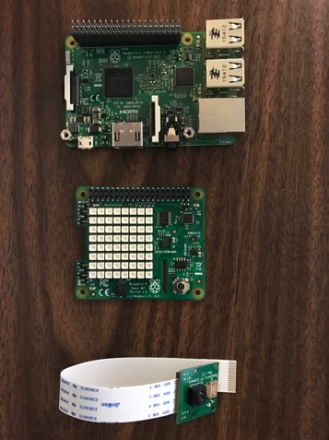

Figure 2 Hardware is used in this project. From left: Raspberry Pi 3, Sense HAT, camera module

To integrate this system, just attach these different pieces in order. The final connected system is in Figure 3.

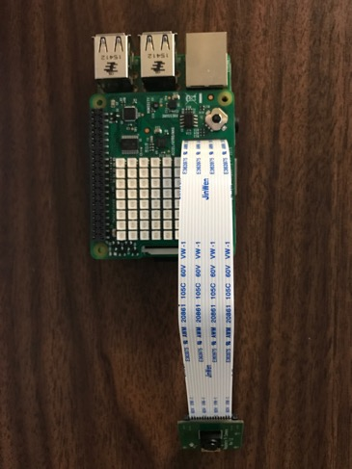

Figure 3. The final assembled system without power cable or HDMI cable

## Operation System, Software, Platform and Code

### Operation System for Raspberry Pi 3

The Raspberry Pi 3 does not ship with a pre-build operating system. In order to boot up the Pi, we need an external micro SD card to load the image.

First, the operating system image could be downloaded at <https://www.raspberrypi.org/downloads/raspbian/> and Raspbian Jessie Lite is preferred. Then follow this installation guide at <https://www.raspberrypi.org/documentation/installation/installing-images/README.md> to write this image to the micro SD card based on your system.

Please select a reliable SD card. The minimum requirement is class 10. I used one class 4 SD card at the beginning. At one time, when I tried to execute some commands to upgrade the OS, the entire file system crashed. Since I didn’t backup and file that time, I had to redo everything.

The first time you boot the Raspberry Pi you will need to have a keyboard, a Mouse and an external screen connected to the Pi to be able to do the initial configuration. It is better for you to have an available network connectivity.

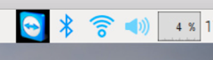

Click Wi-Fi icon to connect Pi to the Interne.

Then open a terminal window to check the IP address use *‘hostname –I’*:

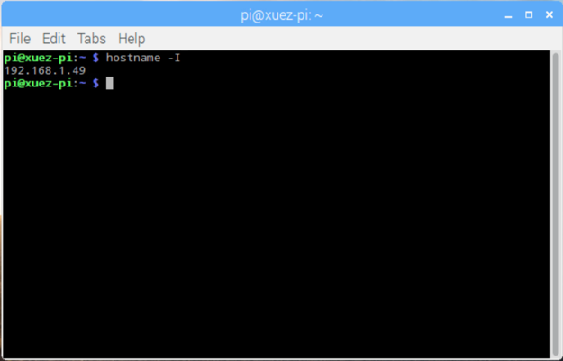

As you have this IP address, you can remote log in the Pi from another computer under the same Internet connectivity.

Then in the *‘Preference’* menu, you are able to configure Pi using a GUI.

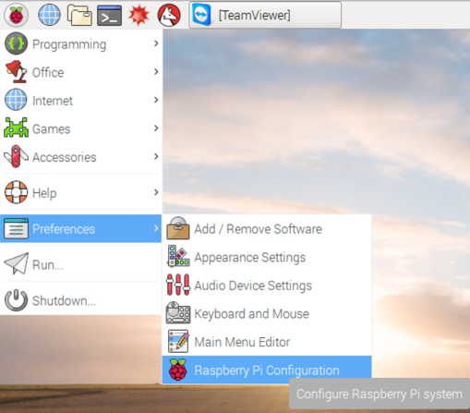

And you are able to change hostname, password and other settings in this GUI.

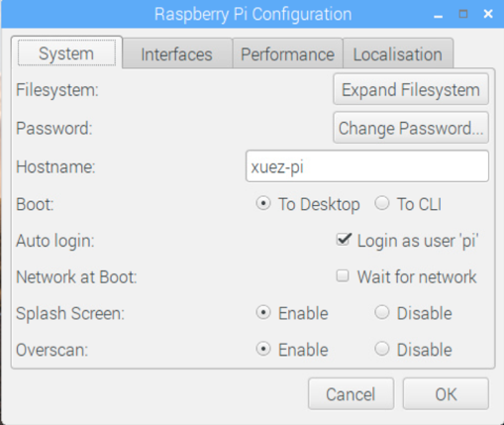

To use camera module, camera interface must be enable.

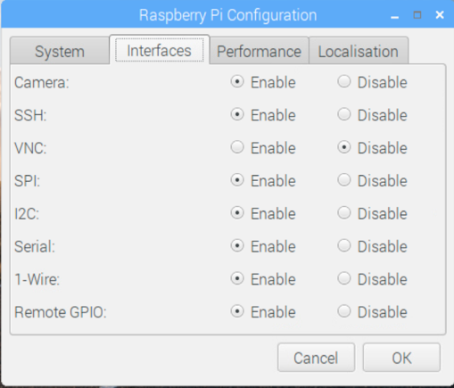

And a reboot is necessary after changing the configuration.

Some packages need to be update:

*sudo rpi-update*

*sudo reboot –n*

The last command will reboot the Pi, after reboot some more commands need to be executed to update the Rasbian OS:

*sudo apt-get update*

*sudo apt-get –y upgrade # if you use a low quality SD card, this will crash the file syste.*

*sudo apt-get –y autoremove*

Updates for Node.js

Node-RED is based on Node.js. And npm version 2 is required:

*sudo apt-get install –y npm*

*sudo npm i –g* [*npm@2.x*](mailto:npm@2.x)

And a final reboot is requited

*sudo reboot –n*

## Software and Platform

### Bluemix

In this project, I use Bluemix and Node-RED to connect local machine and the cloud.

Bluemix is a cloud platform developed by IBM, and it is designed for Internet of Things. Cloud-based project cloud be created on Bluemix.

To use Bluemix, an account has to be signed up at <https://console.ng.bluemix.net/> and an Internet of Things Platform Starter Boilerplates project is the project type I use.



Figure 4 Create a IoT Starter project in Bluemix platform

Project can be viewed in dashboard:



To connect Bluemix and Raspberry Pi, a device should be created in the project dashboard. This is under service -> Internet of Things -> Connect your devices

 

If there is no device in the device list, a new device should be created by clicking the *‘+ Add Device’* button.



A new device type is what I want



In this project, I only use *‘device type’*, then follow the instruction



In security step, a token is recommended. This token will be used in Node-RED when connect device and Bluemix.

And a new device is look like this:



After creating the device type, an API key is also necessary.



The API key and the authentication token is unique and will change each time when new a new key is generated.



This information should be saved into a file to backup.

So far, this device is ready to use in Node-RED and able to connect to Internet.

### Node-RED

Node-RED is browser-based editor that makes it easy to wire flows that can be deployed to runtime in a single click.

In Raspberry Pi, an auto start on boot for Node-RED could be setup:

*sudo systemctl enable nodered.service*

In Pi, the default port for Noed-RED is 1888, launch web browser and redicrect to localhost:1888, and Node-RED is ready to use:



Figure 5 User Interface of Node-RED on Raspberry Pi

As I used Sense HAT, a default component can be found on left column:



The local flow can be established as below:



Figure 6 The workflow of final design

The *‘sensors’* gather raw data from the Sense HAT, then three different functions to extract temperature, humidity and pressure information from this raw data and display on debug console on the right.

Notice, these debug messages are running on local device, the *‘event’* icon on the top actually connect hardware to the Bluemix.



Figure 7 A sample debug console output of sensors data

To connect to Bluemix correctly, the *’event’* node should setup properly.



It should connect as a *‘Device’.* The device type is *‘Registered’*, which means I have already registered this device for my project in the Bluemix. The *‘Credentials’* is the API key I just generated.



The *‘Organization’* ID can be found at top right corner in Bluemix console, under username:



*‘Device Type’* and *‘Device ID’* should match with the information in the Bluemix



And that *‘Auth Token’* is what you have when create a new device type.

If all settings are correct, it is the good time to switch back to Bluemix console and receive data at the cloud.

In dashboard, click the URL of this project, a new webpage will direct to Node-RED editor for this project.

At the Bluemix cloud platform, an input node is used for receiving events sent from device:



The final workflow for the Bluemix is:



In order to publish and display these sensor data via the Internet, I set up a http request and transmit the event messages.

A sample debug console of Bluemix workflow:



Figure 8 A sample debug console output of sensors data on Bluemix

Video streaming is inspired by this thread in Reddit: <https://www.reddit.com/r/raspberry_pi/comments/2ahzp2/raspberry_pi_encoder_live_streaming_to_youtube/> . I followed the instruction to install ffmpeg on the Pi and tune the command a little to fix ISO and adjust resolution to live streaming on YouTube.

### Code

**Streaming video on YouTube:**



The KEY is unique for each person; I hide it here. This key is from YouTube live dashboard.

**Workflow on Raspberry Pi 3:**



**Workflow on Bluemix**:



## Display on the Internet

The final step of this project is to display on the Internet, then I can remotely supervise my apartment.

I use freeboard.io as my dashboard. Freeboard.io is a very simple, easy to use dashboard for IoT devices. My project host on this URL: <https://freeboard.io/board/yfad-v> . Temperature, humidity and pressure are visualized on this dashboard. Meanwhile, a widget on the right side display the YouTube live streaming.



Figure 9 The freeboard.io dashboard

In the Bluemix, I created a HTTP request for my event message, and in this dashboard, I used this URL as my data source, and extract data from this message:



Furthermore, in order to grab the entire message and sent out, a global variable is created in the Bluemix:



With these information, a widget now is able to create and visualize the data in dashboard:



# Conclusions

This project has been a great learning experience in that I was able to choose a suitable development board based on its spec and implement a system with it. In addition, I also learned how to streaming video on YouTube and gain some hand-on experience on Internet of Things, including how to connect device to the cloud and how to use tools to visualize the data. There is also some improvement could be done. Currently, user is only able to monitor data online, in the future, user should have ability to control the device from the Internet. Besides, more sensors could be added into the system and data might store into a database for future research or some other usage.

# Acknowledgements

I would like to thank Dr. Song for giving me this opportunity to start an independent study on this modern topic. I also want to thank my roommate Yingjie Chen. He gave me a lot help for my demonstration.